Tier 5 Certificate of Sponsorship (CoS) Entry Instructions
Note: You cannot enter the UK via the Common Travel Area to work (e.g. via Republic of Ireland e.g. Dublin) unless you already have a visa (the CTA has no UK passport control to activate CoS).
At UK Passport control:
- Present CoS or CoS number to Passport Control officer.
- On receiving passport stamps, you or your UK contact must scan/photograph a copy (see Fig. 1 and Fig. 2 below) as soon as possible on the day of arrival and email to workpermits@cmeas.com
- Failure to copy and send stamps to the sponsor on day of arrival contravenes the sponsors licence with the Home Office and may incur a penalty.
- Please note: WE NEED BOTH STAMPS! They show evidence of entry and leave to remain dates; port of entry; and the passport officer’s ID number.
Holders of Tier 5 Certificates of Sponsorship (CoS) enter the UK with two stamps on the same page in their passport: a leave to remain endorsement and a date of entry stamp.
Visa nationals will have a visa that is their leave to remain entry endorsement stamped in their passport before they travel. This then receives a date of entry stamp on arrival to the UK (Fig. 1.)
Non-visa nationals will receive their leave to remain endorsement when they pass through UK passport control and also receive a date of entry stamps (Fig. 2.)
Fig. 1. A visa national entry endorsement showing the visa stamp and the date of entry stamp.
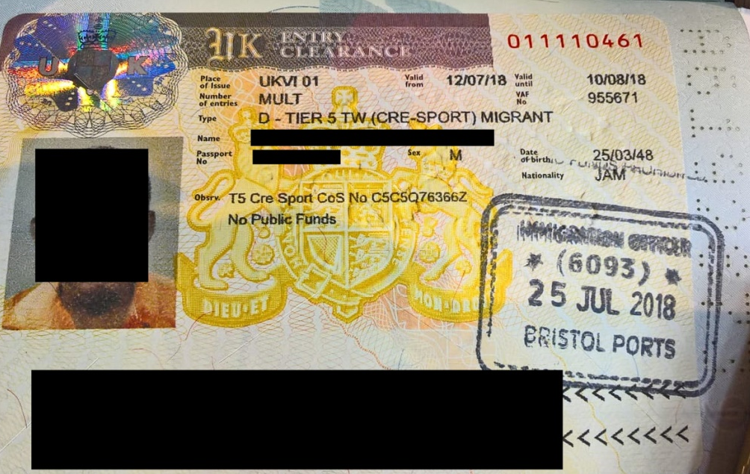

Fig. 2. A non-visa national entry endorsement showing the leave to remain stamp and the date of entry stamp.
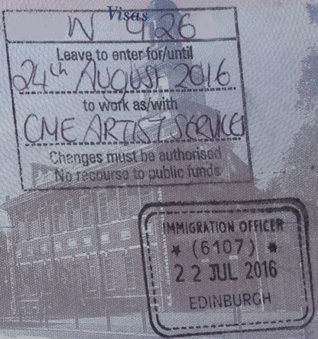
Note: If you are not travelling on a visa and only receive the date of entry stamp in your passport you have been entered as a non-working visitor and need to alert the passport officer to activate your CoS and re-stamp your passport correctly

Thank you for your co-operation.
CME Artist Services

